Rest API SharePoint Connector
Purpose
Connect to the Finance SharePoint site to facilitate building of reports to provide detailed financial insights to drive business performance.

Tables to GET from finance SharePoint
- GL Lookup
- Product Lookup
- Cost Centre Lookup
- WBS Lookup
- Budget files

Data Flow Diagram
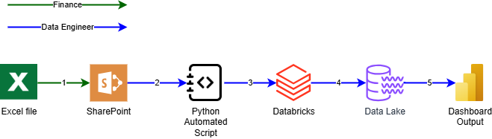

- Finance: Updates the existing file in SharePoint directory
- Data Engineer: Scheduled job would trigger the API notebook to request a GET activity from the specified SharePoint Directory to obtain data.
NOTE: Schedule would be agreed with Finance team (Daily/weekly/monthly…)
GET – Is a way for you to grab data from a specific data source/resource
- Data Engineer: The triggered job that runs the notebook, GET and extracts the data from the excel file, and the extracted data would create a Data Frame of the Excel data.
Data Frame – is a data structure constructed with rows and columns.
The current job continues the data pipeline that cleans and formats the data ensuring dates are in date format, numbers are in integer format etc…
The data pipeline transitions into different stages to ensure data quality:
Raw > Bronze > Silver > Gold.
Raw = Extracted data
Bronze = Provides metadata (Ingest date & Unique ID)
Silver = Cleaning the data
Gold = Business use case aggregations
- Data Engineer: The Data is stored as a table in our data lake.

- Data Engineer: Data is passed to BI Developer to develop dashboard for reporting. The BI Dev, connects up using the available data source connectors in PowerBI, enabling a seamless flow.

